;l

Foundations of Programming

Assignment No: 8

PROBLEM STATEMENT:
Write a program in C to accept marks of five courses of a student and compute the result. A student is considered PASS if he/she scores 40 marks or more in each course. If the student passes, calculate the aggregate percentage and assign the grade as follows:
- Aggregate ≥ 75% : Distinction
- Aggregate ≥ 60% and < 75% : First Division
- Aggregate ≥ 50% and < 60% : Second Division
- Aggregate ≥ 40% and < 50% : Third Division

OBJECTIVE:
- To understand the use of conditional statements in C
- To apply logical operators for decision making
- To calculate total, percentage, and grade of a student
- To enhance problem-solving skills using real-life scenarios

THEORY:
In academic evaluation systems, student performance is assessed based on individual subject marks as well as overall aggregate performance. In C programming, such evaluation systems can be implemented using conditional statements like if, else if, and else. Logical operators help in checking multiple conditions simultaneously. Percentage calculation involves arithmetic operations, and grading logic is implemented based on predefined ranges. This program demonstrates structured programming and decision-making in C.

ALGORITHM:

Step 1: START

Step 2: Declare variables — a, b, result, choice

Step 3: Input two numbers a and b

Step 4: Display Menu

1. Addition

2. Subtraction

3. Multiplication

4. Division

5. Exit

Step 5: Input choice from user

Step 6: Check choice using switch/if-else:

If choice = 1:

result = a + b

Print result → Go to Step 4

If choice = 2:

result = a - b

Print result → Go to Step 4

If choice = 3:

result = a × b

Print result → Go to Step 4

If choice = 4:

If b == 0 → Print "Division by Zero Error"

Else result = a / b → Print result

Go to Step 4

If choice = 5:

Print "Exiting..." → Go to Step 7

Else:

Print "Invalid Choice" → Go to Step 4

Step 7: STOP

Flowchart (Text Form)

[START]

|

[Input: a, b]

|

[Display Menu]

|

[Input: choice]

|

[choice == 5?] —YES—> [EXIT] -> [STOP]

|

NO

|

________|________

| | | |

c=1 c=2 c=3 c=4

| | | |

a+b a-b a*b [b==0?]

| | | YES | NO

| | | [Error] a/b

| | | |

[Print result]----+

|

[Go back to

Display Menu]

Key Points
Choice | Operation | Special Case
1 | a + b | None
2 | a - b | None
3 | a × b | None
4 | a / b | Check b ≠ 0
5 | Exit | Terminate loop

In academic evaluation systems, student performance is assessed based on individual subject marks as well as overall aggregate performance. In C programming, such evaluation systems can be implemented using conditional statements like if, else if, and else. Logical operators help in checking multiple conditions simultaneously. Percentage calculation involves arithmetic operations, and grading logic is implemented based on predefined ranges. This program demonstrates structured programming and decision-making in C. GIVEW ALGO

9:38 AM

Algorithm – Student Grade Evaluation System

Step 1: START

Step 2: Declare variables — m1, m2, m3, m4, m5 (marks), total, percentage, grade

Step 3: Input marks for 5 subjects

Enter marks for Subject 1 → m1

Enter marks for Subject 2 → m2

Enter marks for Subject 3 → m3

Enter marks for Subject 4 → m4

Enter marks for Subject 5 → m5

Step 4: Validate Marks

If any mark < 0 or > 100 → Print "Invalid Marks" → Go to Step 3

Step 5: Calculate Total

total = m1 + m2 + m3 + m4 + m5

Step 6: Calculate Percentage

percentage = total / 5

Step 7: Determine Grade using conditions
Condition | Grade
percentage >= 90 | A+
percentage >= 80 | A
percentage >= 70 | B
percentage >= 60 | C
percentage >= 50 | D
percentage < 50 | F (Fail)

Step 8: Check Pass / Fail condition

If any subject mark < 40 → Print "FAIL (Failed in a subject)"

Else If percentage < 50 → Print "FAIL"

Else → Print "PASS"

Step 9: Display Results

Print total

Print percentage

Print grade

Print Pass / Fail status

Step 10: STOP

PLATFORM: Linux
PROGRAM :
#include <stdio.h>

int main()
{
float Percentage,E, M, S, SS, C, Total;

printf("Enter marks obtained in English: ");
scanf("%f", &E);
printf("Enter marks obtained in Math: ");
scanf("%f", &M);
printf("Enter marks obtained in Science: ");
scanf("%f", &S);
printf("Enter marks obtained in Social Studies: ");
scanf("%f", &SS);
printf("Enter marks obtained in Computer: ");
scanf("%f", &C);

if (E < 40 || M < 40 || S < 40 || SS < 40 || C < 40)
{
printf("Student is Fail\n");
return 0;
}
else
{
Total = E + M + S + SS + C;
Percentage = (Total / 500) * 100;

printf("Total Marks: %f\n", Total);
printf("Percentage: %.2f%%\n", Percentage);

if (Percentage >= 75)
{
printf("Grade: Distinction\n");
}
else if (Percentage >= 60 && Percentage < 75)
{
printf("Grade: First Division\n");
}
else if (Percentage >= 50 && Percentage < 60)
{
printf("Grade: Second Division\n");
}
else if (Percentage >= 40 && Percentage < 50)
{
printf("Grade: Third Division\n");
}

return 0;
}
}

Flowchart :
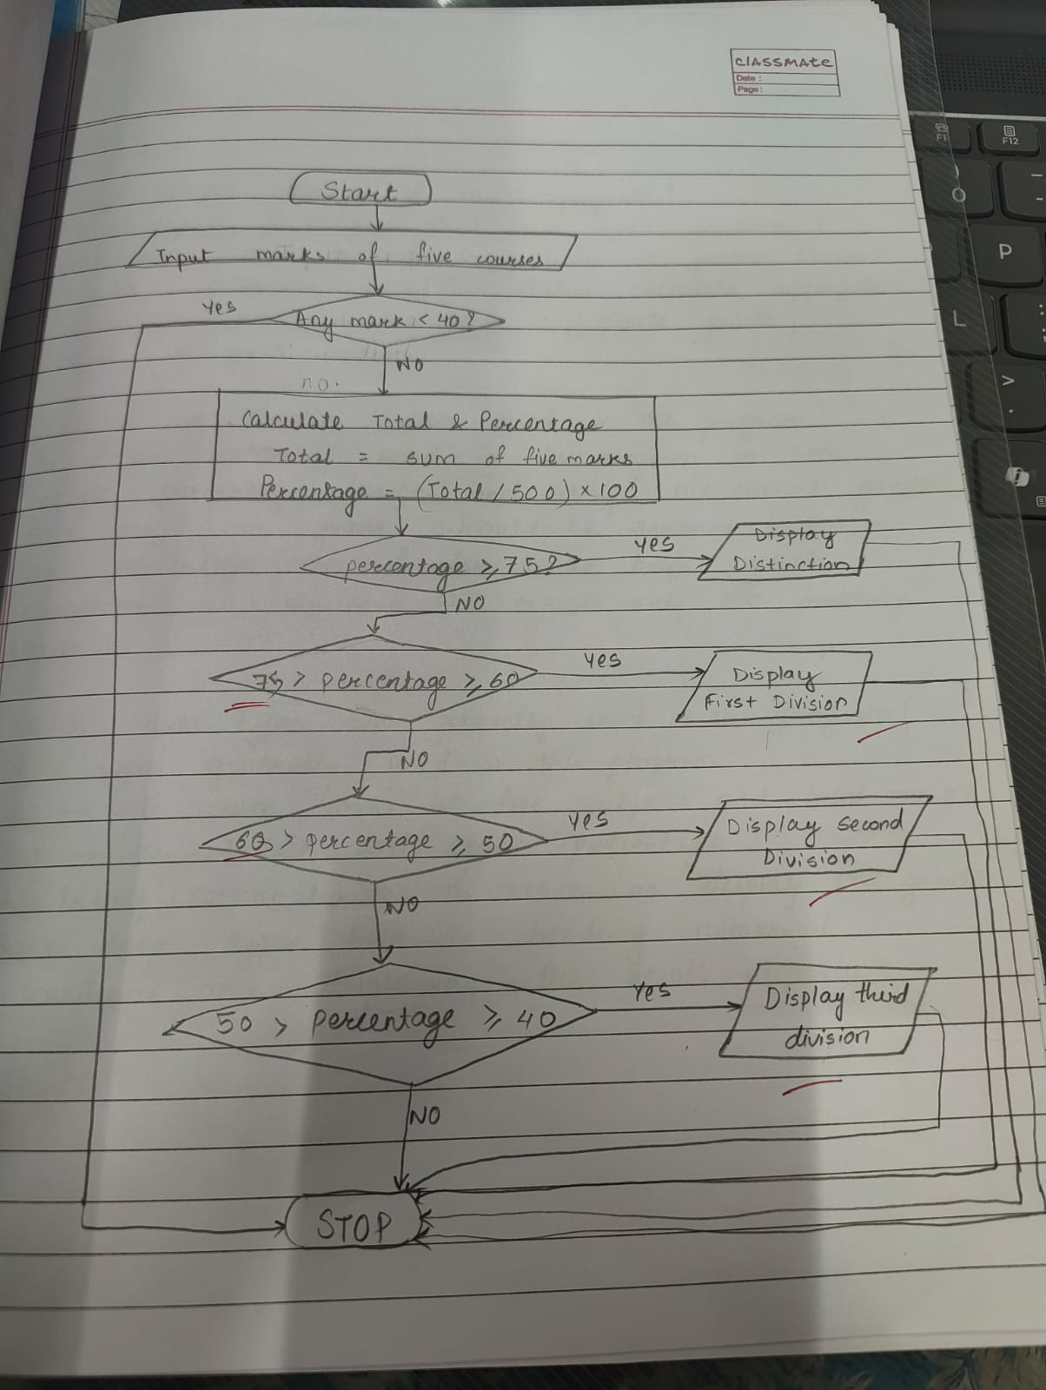

INPUT:
The user enters marks of five subjects.
Example Input:
Marks: 78 65 70 80 75
Paste Screen Shot

OUTPUT: The program displays the total marks, percentage, result, and grade.
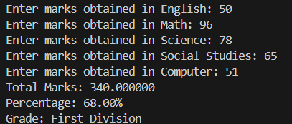
CONCLUSION: Thus, the program to calculate student result and grade based on marks was successfully implemented using C programming. This program demonstrates the effective use of conditional statements, logical operators, and arithmetic operations.

FAQs:
- What is the objective of this C program?
- Why is an if–else ladder used in this program?
- Which data types are generally used in this program?

